
Comsats University Islamabad, Lahore Campus

Lab Assignment <2> – SPRING 2025
Course Title | Software Testing | Course Code |  | CSE455 | Credit Hours |  |  | 3(2,1)
Instructor/s | Ms. Yella Mehroze | Program Name |  | BSSE
Semester | 8th | Batch | FA21 | Section | A | Date | March 19, 2025
Time Allowed | 1 week | Maximum Marks
Student Name: | Aoun-Haider | Reg No. |  | FA21-BSE-133

Question Statement [CLO-2]; Bloom Taxonomy Level: <Applying>
Test case creation
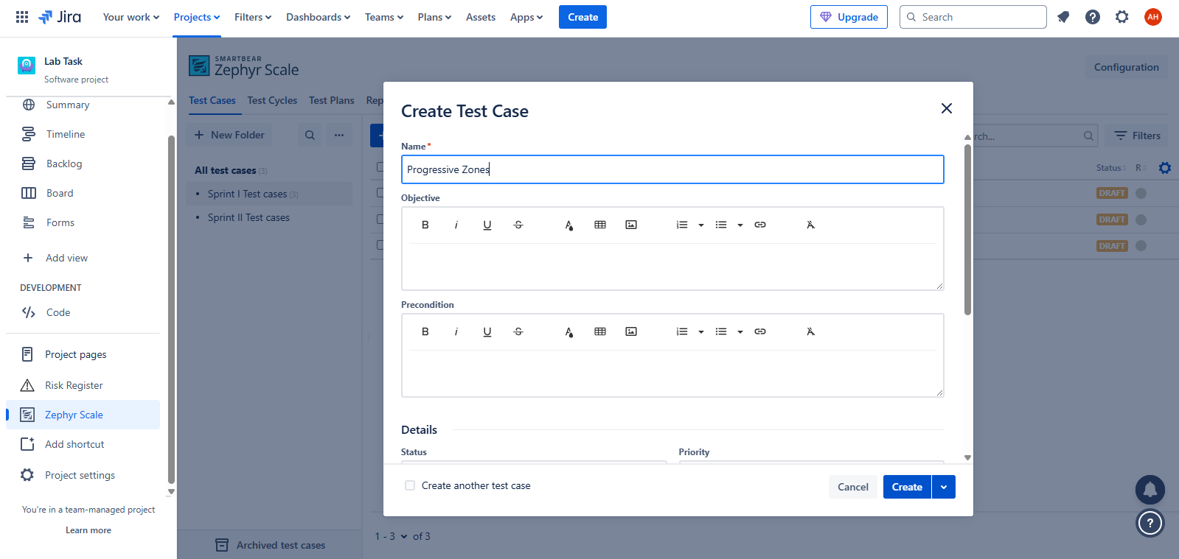

Adding test scripts:
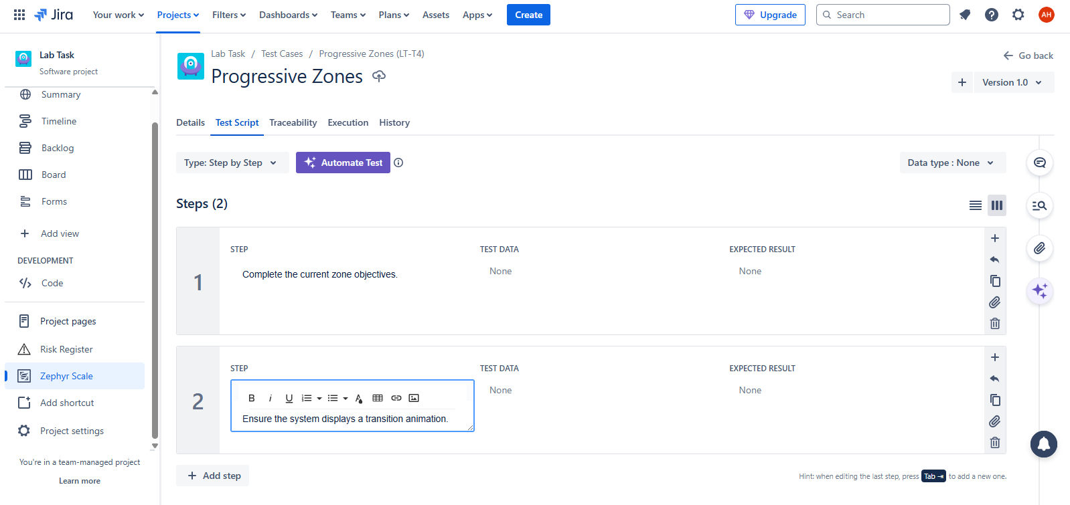
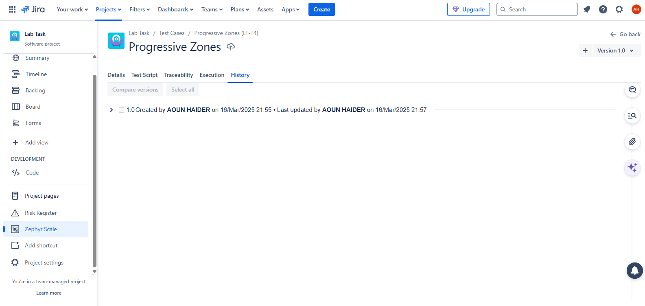

Organizing test cases in folders with respect to each sprint
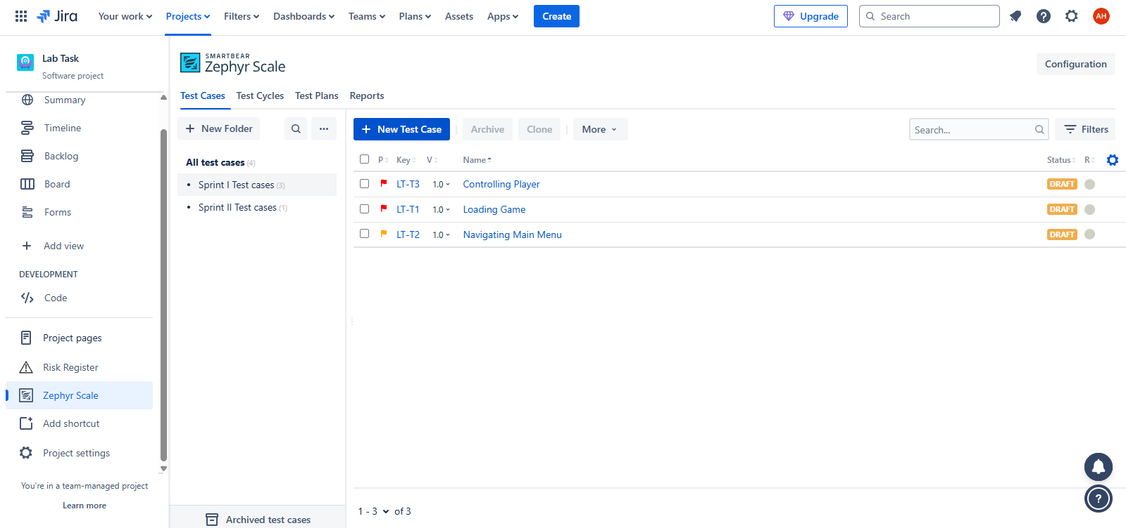
Adding Filters on test cases
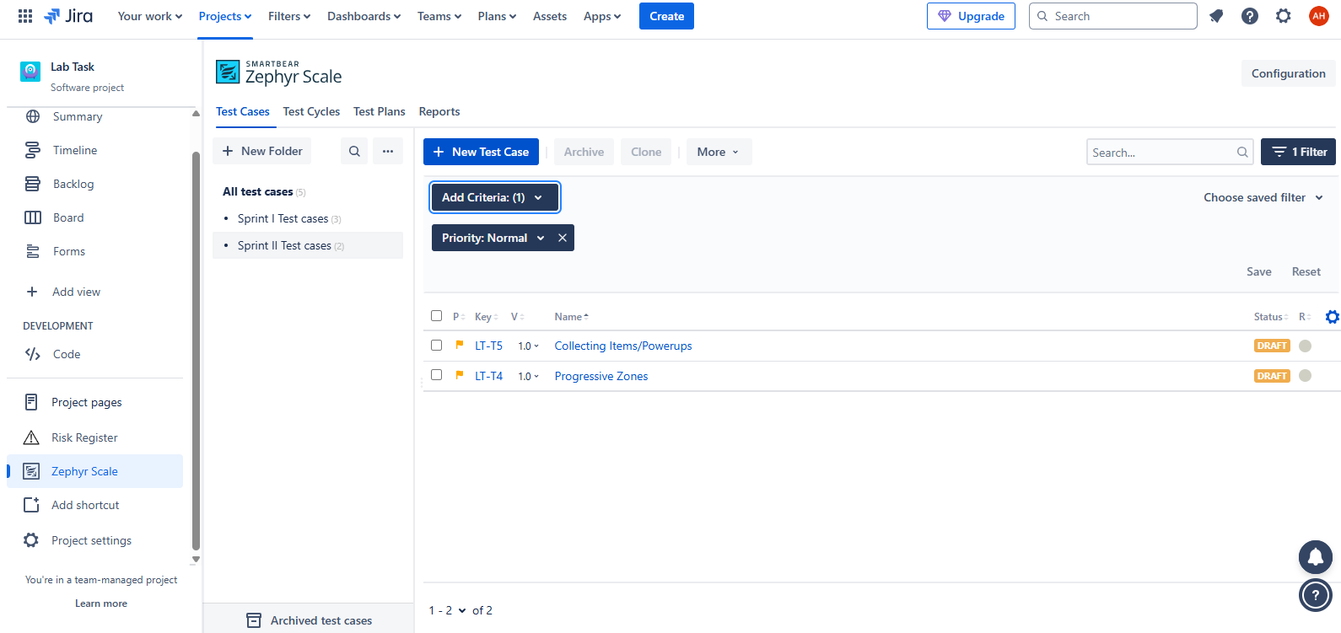

Creating test cycle
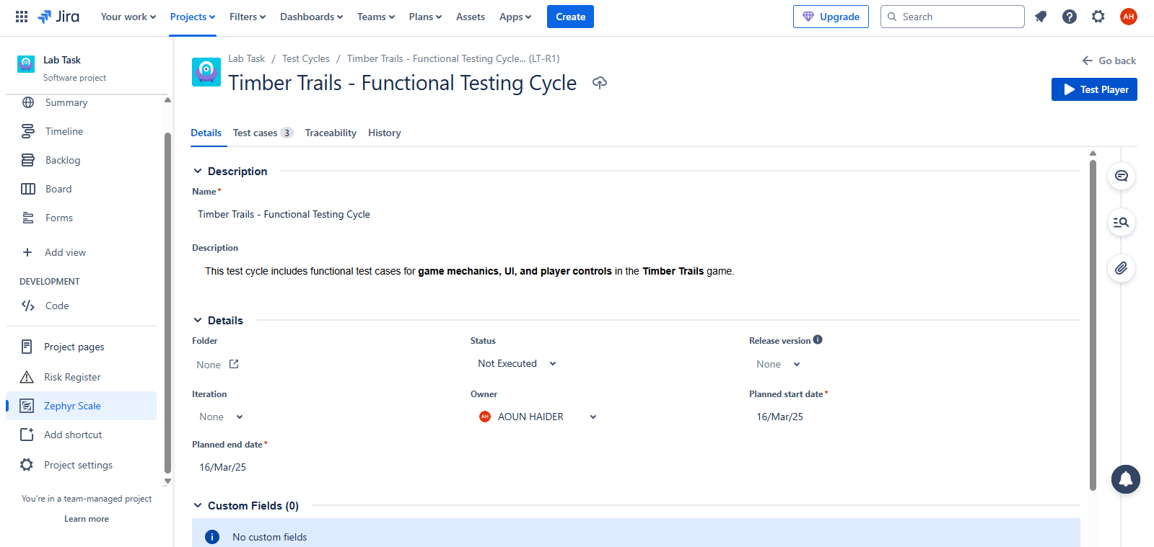
Adding test cases to test cycle
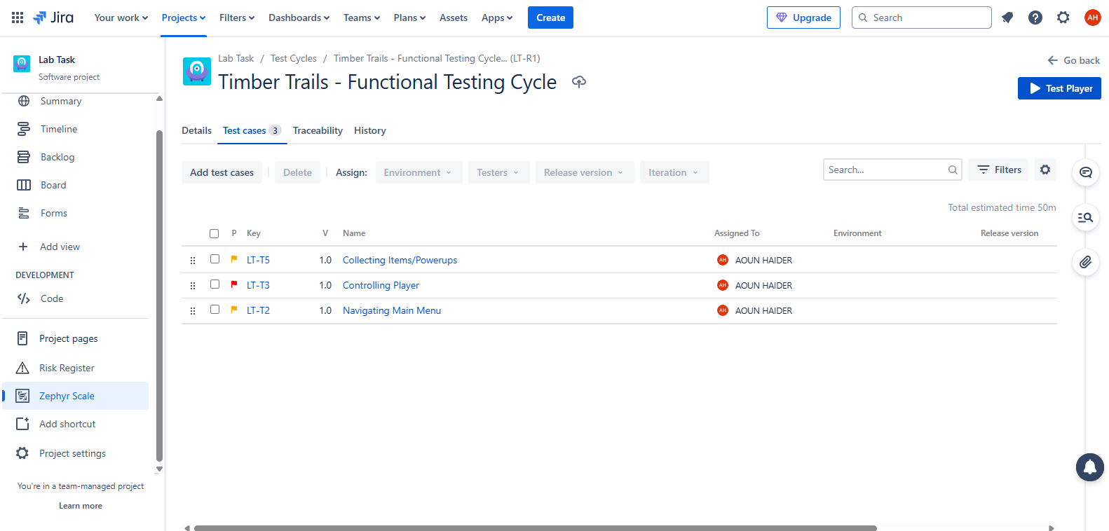

Executing test cycle
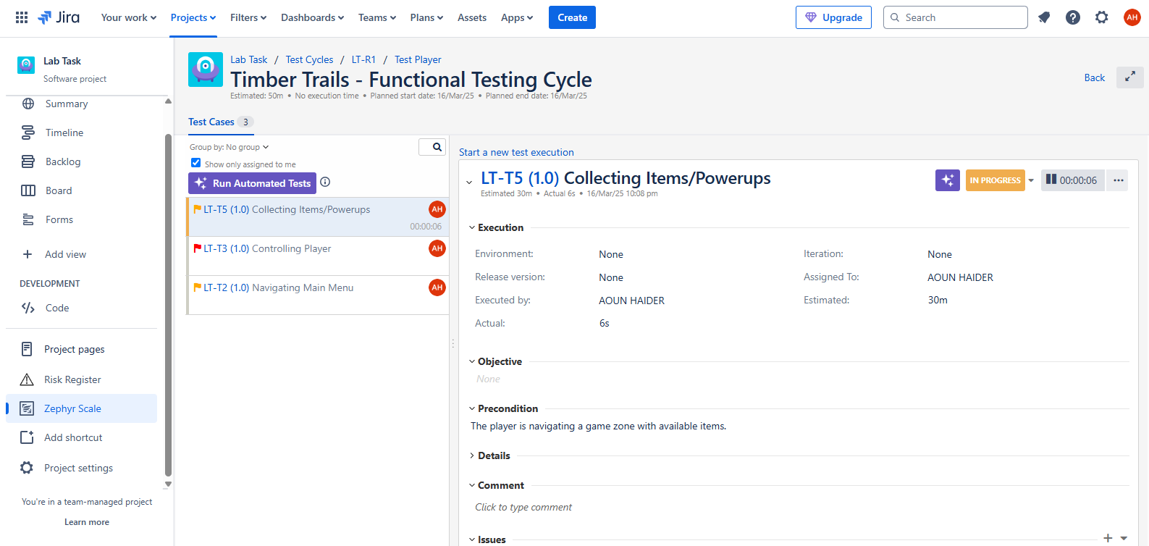
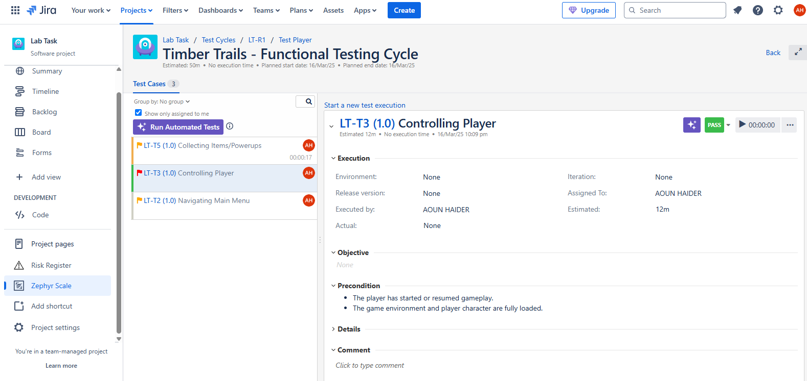
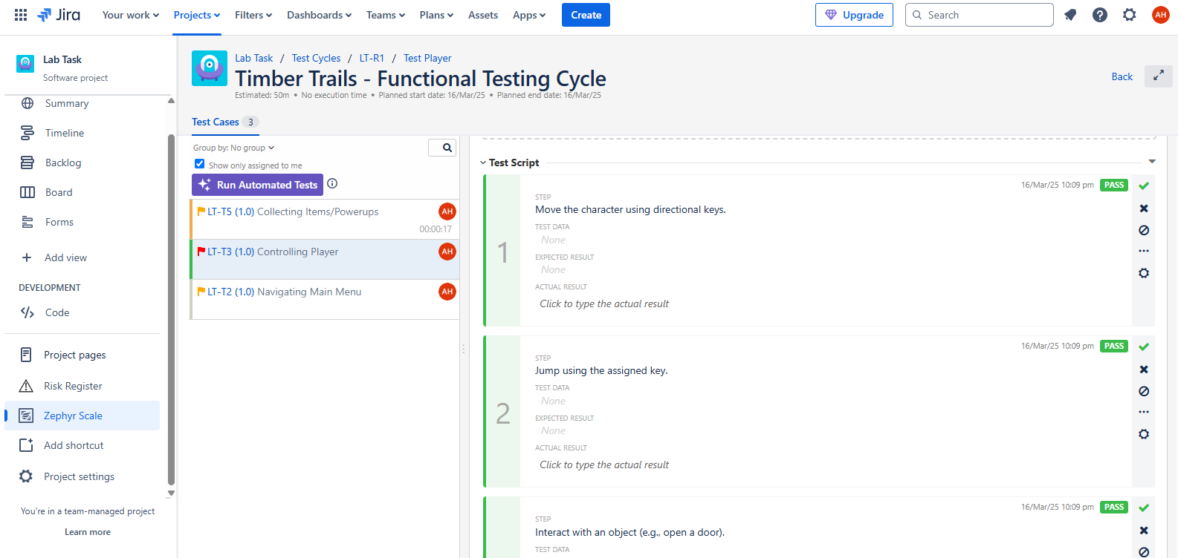
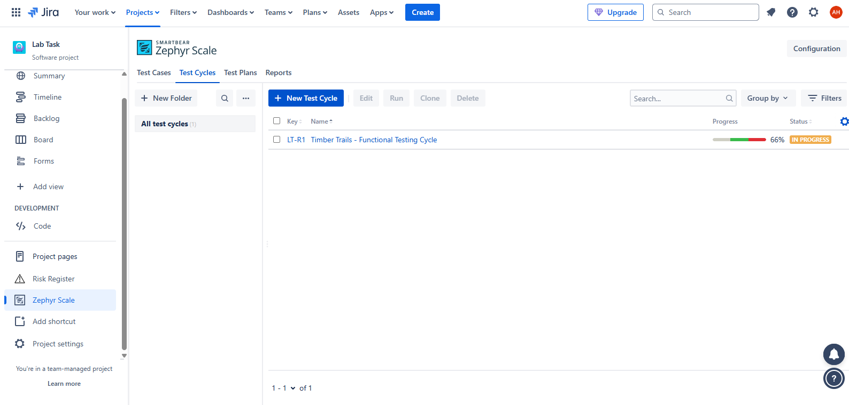

Creating test plan
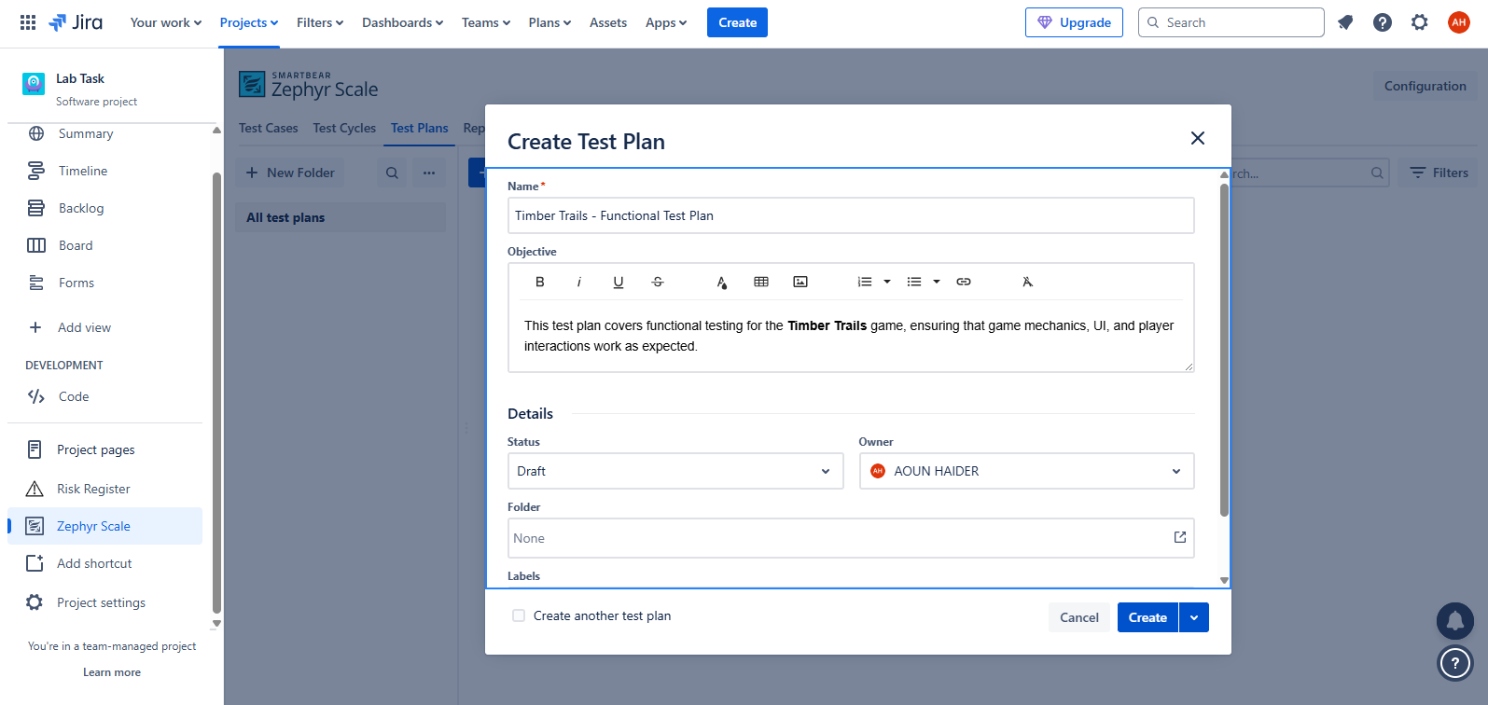
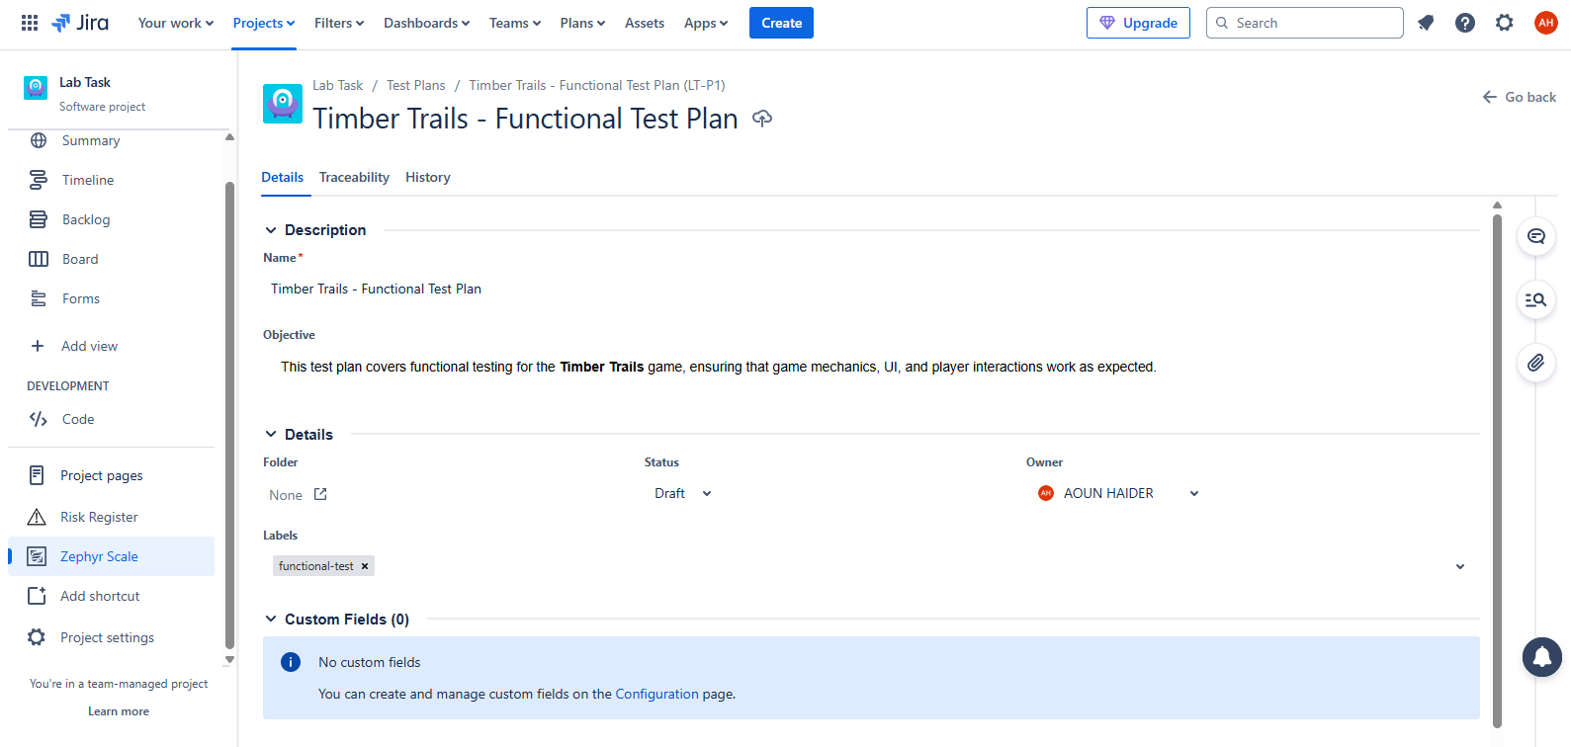

Observing test report
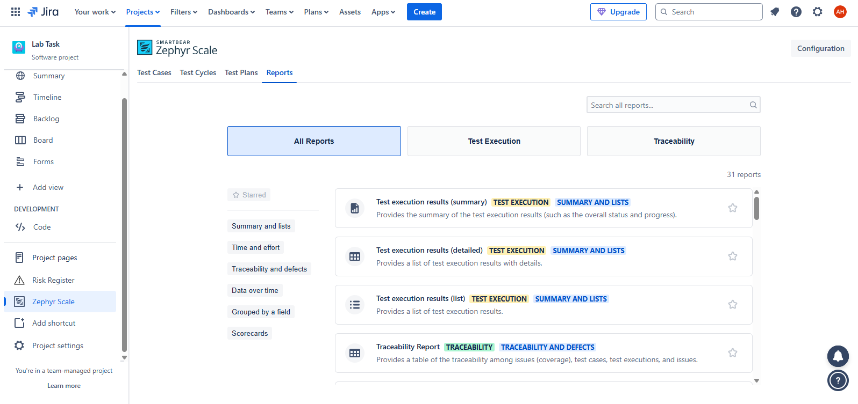
Connecting test plan with test cycle
